EXP3: MATLAB SIMULATION OF SUPERHETERODYNE RECEIVER FOR AM COMMUNICATION SYSTEM WITH FREQUENCY MIXING AND FILTERING

Objectives
i) To model and simulate the operation of a superheterodyne receiver for an AM communication
system using MATLAB by implementing frequency mixing and intermediate frequency (IF)
signal generation.
ii) To recover the original message signal through intermediate frequency filtering and envelope
detection, and analyze the waveforms of the message, carrier, AM, IF, and recovered signals.

PROGRAM (MATLAB CODE)
clc;
clear;
close all;
% Parameters
fs = 100000;
t = 0:1/fs:0.02;
fm = 500; % Message frequency
fc = 10000; % Carrier frequency
fLO = 14550; % Local Oscillator (IF = 4550 Hz)
% Message Signal
m = cos(2*pi*fm*t);
% Carrier Signal
c = cos(2*pi*fc*t);
% AM Signal
am = (1 + m).*cos(2*pi*fc*t);
% Local Oscillator
LO = cos(2*pi*fLO*t);
% Frequency Mixing
mixed = am .* LO;
% IF Filter
[b,a] = butter(4,5000/(fs/2));
IF = filter(b,a,mixed);
% Envelope Detection
env = abs(hilbert(IF));
% Display
figure;
subplot(4,1,1)
plot(t,m)
title('Message Signal')
grid on
figure;
subplot(5,1,2)
plot(t,c)
title('Carrier Signal')
grid on
subplot(5,1,3)
plot(t,am)
title('AM Signal')
grid on
subplot(5,1,4)
plot(t,IF)
title('Intermediate Frequency (IF) Signal')
grid on
subplot(5,1,5)
plot(t,env)
title('Recovered Signal')
grid on

Procedure:
1. Open MATLAB and create a new script.
2. Enter carrier amplitude, carrier frequency, message amplitude, message frequency, sampling
frequency and selected IF.
3. Generate the message signal.
4. Generate the RF carrier signal.
5. Generate the conventional AM signal.
6. Generate the local oscillator; for high-side injection use f_LO = f_RF + f_IF.
7. Multiply the AM/RF signal and local oscillator to perform frequency mixing.
8. Use FFT to identify the mixer sum and difference components.
9. Design an IF band-pass filter centred at f_IF and apply it to the mixer output.
10. Plot the filtered IF waveform and its spectrum.
11. Perform envelope detection on the filtered IF signal.
12. Apply a low-pass filter to recover the message.
13. Plot original and recovered messages together.
14. Compare message, carrier, AM, IF and recovered waveforms.
15. Calculate frequency deviation/error where required and record observations

OUTPUT
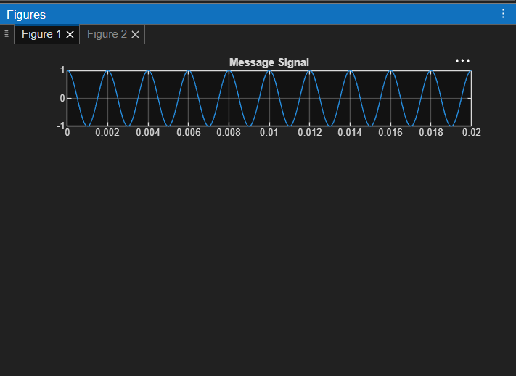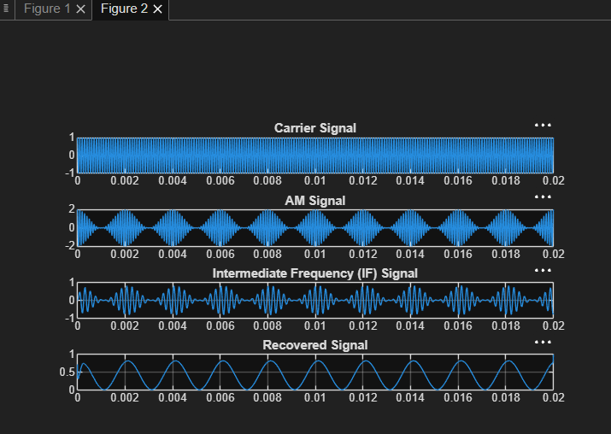

Result:
The superheterodyne receiver was successfully simulated in MATLAB, and the message signal, carrier signal, AM signal, Intermediate Frequency (IF) signal, and recovered signal were obtained through frequency mixing and filtering

